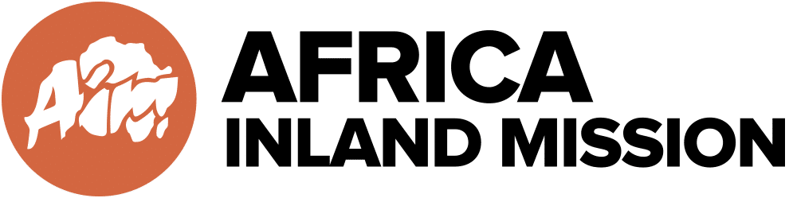

- One-week prayer trip to an unreached people group in North Africa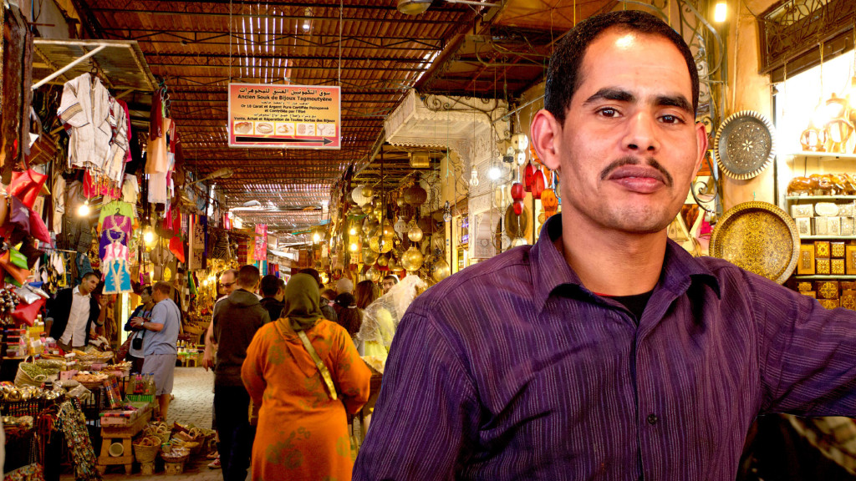
North Africa team
Do you want to know more about what it’s like to serve in a closed country? Are you prepared to be challenged in your walk with God? To widen your cultural boundaries? To pray for God to move in a challenging context?
Background
God is moving in powerful ways in the countries of North Africa. If you’re interested and considering how you can play a role in sharing the gospel in these nations, then why not come on this week long short term trip and explore how you could get involved? Join a team of like-minded people for one week, learn from long term workers and engage in hands on ministry.
Ministry and type of work
You will explore the local culture, investigate barriers to faith and understand more about what ministry looks like in this context, as well as spending a lot of time praying for and encouraging those working in this area long term. We will also be running a holiday club for the ministry workers children.
Qualifications and experience
- An interest in supporting or serving in ministry in closed countries, particularly North Africa
Other information
- This team will be led by an experienced missionary.
- The team usually runs once per year during the summer months, there are limited spaces available on the team for security reasons.
- The dates for this team are: July 30th – August 6th 2022.

The provisional budget is £775. It might come down a bit closer to the time. Prayer, a bit of kid’s work and, if the Lord leads, some sharing of our faith with locals. It’s going to be mind-blowing!

- One-week working with unreached people group in UK
The second team we are doing is UK based – in the Midlands – from Saturday 30th July – Sunday 7th August. The budget for that is £375. Info at https://eu.aimint.org/opportunities/community-outreach-week-uk-diaspora/
Working with a church amongst an unreached people here in the UK – superb opportunity.

Don’t forget to ask your church about ways they can help you to raise support. You can also earn the money, apply for grants, organise a sponsored event or hold an information evening about what you will be involved in. Further guidance on raising support will be given once you have been accepted onto the short-term programme.
Visit our website: https://eu.aimint.org/opportunities/north-africa-team/

