***Explore Army Chaplaincy***

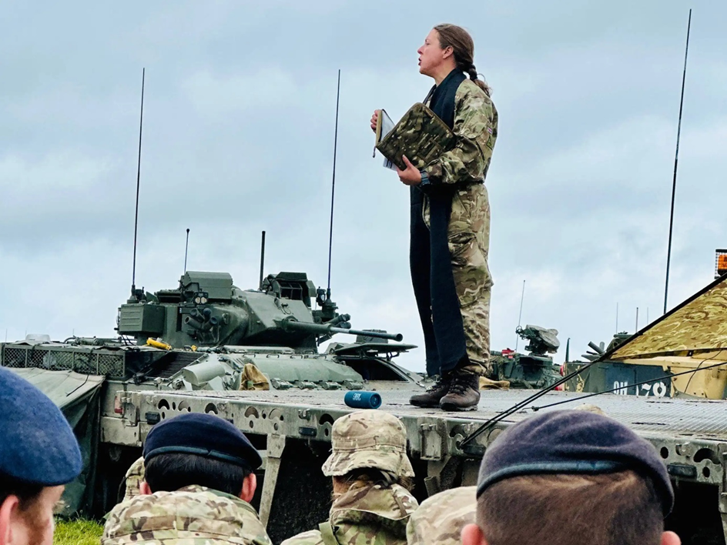

**The Theological Student and Potential Chaplains Course**

**What**: To provide an awareness of military chaplaincy, the course comprises a mixture of lectures, visits, and interaction with serving Army Chaplains and soldiers. There is plenty of time for discussion and quiet contemplation. There is an additional opportunity to then attend a placement inside a British Army Regiment to experience ministry alongside an Army chaplain at Regimental duty.

**Where:** Royal Artillery Barracks & School of Artillery, Larkhill, Wiltshire SP4 8QT

**When**:15 – 19 September 2025

* Optional placements are from 22 – 26 September 2025 and can be arranged at Aldershot, Catterick, and Tidworth

**What is an Army Chaplain?**

**A Vocation as an Army Chaplain or Non-Religious Pastoral Officer**

Life as an Army Chaplain is a calling like no other. Belonging to a remarkable organisation of young men and women, sharing your life with them, and serving alongside them wherever they go brings tremendous opportunities and challenges. It is a vocation that is both demanding and rewarding and offers an adventurous journey of faith.

**Caring for the Army’s People**

The purpose of the Royal Army Chaplains’ Department is to care for the Army’s people. Our Chaplains, who are Professionally Qualified Officers, deliver pastoral care to everyone, facilitate spiritual support, and offer moral guidance to the whole force and their families irrespective of faith, world philosophy or status.

Interested in finding out more contact:

Judith Ashbee

Email: [Judith.ashbee855@mod.gov.uk](mailto:Judith.ashbee855@mod.gov.uk)

Mobile: 07970 506867

**Air/rail fares, food and accommodation are provided.**